S.C.O.R.E. Scheduling User Manual

By: Will Crawford

Sabba Petri

Eric Stegall

Benjamin Ross

Justin Lazaro

Table of Contents

General Overview 1

1.0 Learning the Application 1

1.1 System Overview 1

1.2 Definitions 2

1.3 System Requirements 2

Getting Started 4

2.0 Accessing the Application 4

2.1 Connecting to Application (All Users) 4

2.2 Program Administrator 5

2.3 Program Manager 7

2.4 Lecturer 8

2.4 Student 10

MEOW. 13

# General Overview

## System Overview, Definitions, System Requirements

Zomg. Random Picture?

### 1.0 Learning the Application

### 1.1 System Overview

The MyCourses Scheduling System will allow program administrators, program managers, lecturers, and students to create, assign, detail, and sign up for courses.

The purpose of this application is to provide a mechanism for departments to submit updates, additions or deletions via the web for future course offerings, and allow aggresive control for each user of the system. MyCourses replaces the paper-based process, which was cumbersome, and brings the entire system online.

With consideration to each user, the program administrator will provide the constraints by listing the possible courses, times, and locations, while the program manager designates and determines which courses and lecturers will be offered for that particular quarter. The lecturer takes the role of filling out the constraints and information about the course and lastly, the student signs up for the courses they desire.

From within this end-to-end system, there is an incorporated algorithm that performs the function of automatically scheduling courses, based on a list of constraints provided by the user. The system then parses these constraints and supplies a list of categorized classes for the user to handle at their discretion.

The architecture of this scheduling system provides for a powerful two-tiered system: a web server based on Django, and a genetic algorithm based on Python. While Django supplies an abstracted framework for dynamic websites, Python is portable, highly scalable, and strongly stable.

MyCourses also provides a strongly intuitive user interface, varying for each user of the system. The minimalist design helps bring the most important functions forward for the user, while its feature-heavy structure allows for stronger power. This combination of style and power brings about an instinctive attraction to any user of the system.

### 1.2 Definitions

* MyCourses – The end-to-end course scheduling system.
* PA (Program Administrator) – User handling the entire MyCourses system.
* PM (Program Manager) – User handling each individual department’s program and course offerings.
* Quarter Course List – This will be a list of courses to be offered in any particular quarter, provided that each quarter be unique and independent from other quarters.
* MyPortal – This is the main user interface (on the web browser) that each user will be interacting with.
* Users – Users can be considered any user of the MyCourses system.

### 1.3 System Requirements

* PC/Mac Requirements:
  + Any machine with an internet connection is required. A printer with the capability of printing schedules and web pages is optional.
* Software Requirements:
  + Internet Explorer, Mozilla Firefox, Google Chrome, Apple Safari, and most browsers are compatible with MyCourses. Latest version of each browser is recommended for optimal viewing, yet not required.

# Getting Started

## Connecting to Application, Program Administrator, Program Manager,

## Lecturer, Student

### 2.0 Accessing the Application

### 2.1 Connecting to Application (All Users)

In your browser, type in the URL provided by your institution.

The Welcome page will appear. Once connected to the site, you may then save it by using the “Favorites” or “Bookmarks” drop down menu, often located at the top of the toolbar of the browser. By doing this, it will eliminate the need to retype the URL every time the user returns to the page.

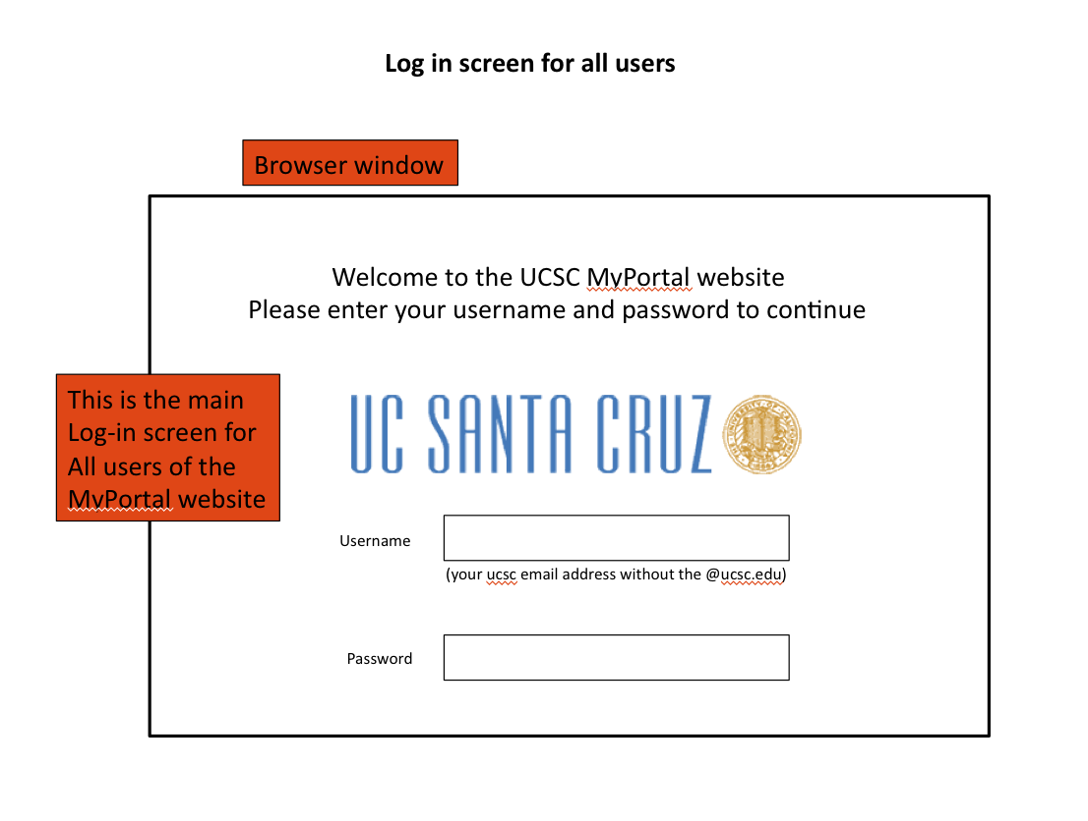

*Figure 1*

* Once the screen appears, the user has the ability to enter their credentials to gain access to MyPortal. Each user affiliated with the institution system will have a specific username and password for access.
* If a user does not have a username or password, they should contact the institution to gain access privileges.
* After inputting credentials, click on [soon to be] Login button.

### 2.2 Program Administrator

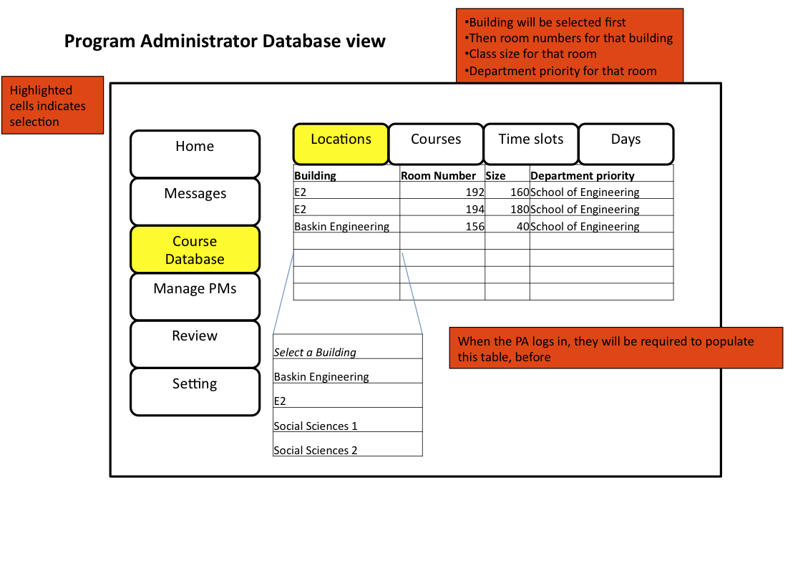

*Figure 2.*

The Program Administrator functions similar to any department user, of whom would be in charge of the overall MyCourses system and managing the database across all departments.

1. You will need to sign into the browser-based MyCourses Portal with your username and password. (As shown in 2.1)
2. Once logged in, as shown in Figure 2, you will enter your MyPortal. A notice will pop up indicating that the database needs information to be filled in order to continue.
3. When clicking on Course Database, it opens an empty table in a spreadsheet format.
4. The top of the table requires will need the following information:
   1. Under Locations tab, a list of all classrooms and buildings available.
      1. Building, room number, size, and department priority.
      2. You will need to enter each classroom organized by building. (i.e. (building) Baskin Engineering 🡪 (classroom) BE156) Also room number, size, and department priority.
      3. Subject preference. (i.e. Social Sciences belong with Sociology)
   2. Under the Courses tab, enter list of all the daily courses during the quarter.
      1. This will be submitted separately into a database table by the Program Manager. (Computer Science 🡪 CMPS115)
      2. Initially, each of the classrooms will be completely free and available unless otherwise noted.
   3. Under the Time Slots and Days tabs, enter time slots and dates respectively, available to all the classrooms.
      1. You will need to fill each section with a certain time. (i.e. (day) Monday Wednesday, and Friday)
      2. Under the Days tab, enter a list of times for the courses offered.
5. Once the information has been filled, Click Submit and the information will be stored. The Program Manager can then start determining which courses to offer for the next quarter.

### 2.3 Program Manager

### 2.4 Lecturer

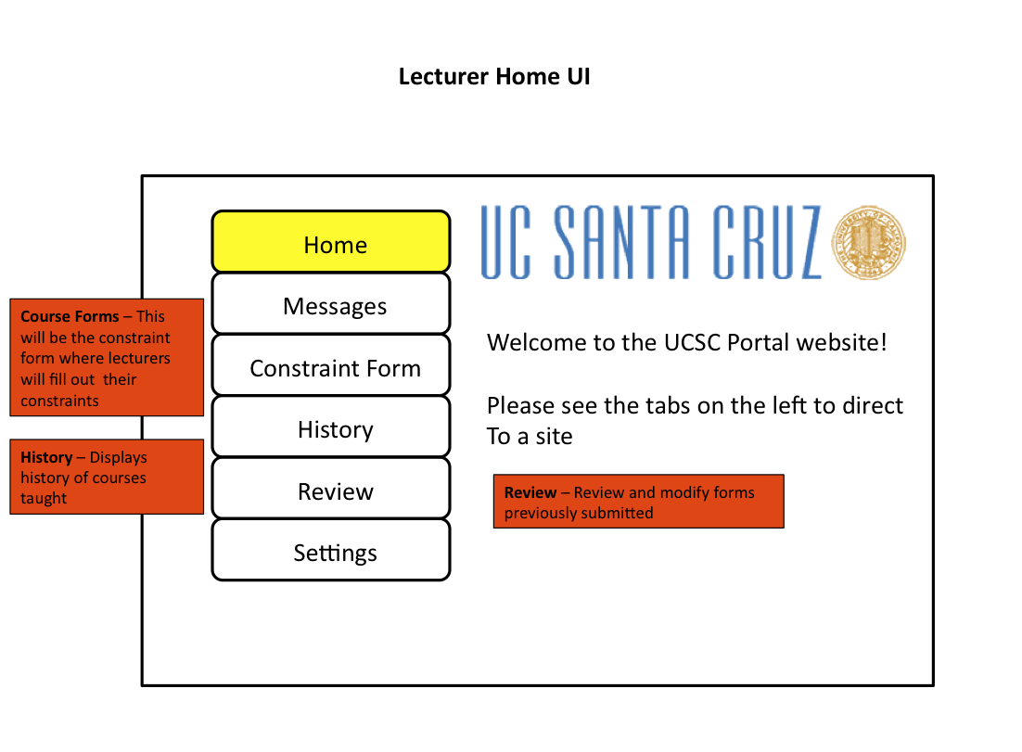

Figure 4.

When you first log into the MyCourses System before the new quarter begins, you will have to submit constraint information for the system. As depicted in Figure 4, you need to click on Course Forms.

1. First, you need to sign into the browser-based MyCourses Portal with your username and password. (As shown in 2.1)
2. Once logged in, a message will pop up, indicating that you have not yet filled out your personal information for your constraints for the quarter and therefore, must complete it to continue using the MyCourses portal
3. Clicking on the Course Forms tab, leads to a set of constraints. This is similar to the Program Administrators database page (Shown in 2.2), which includes in pull down-menu-style:
   1. Under the Courses Tab, you will be able to view the courses available, predetermined by the Program Manager. From here, you must choose from the multiple courses available.
   2. Under the Time Tab, you will be able to choose the preferred time slots available, according to your personal schedule that quarter.
   3. Under the Days Tab, you will be able to choose the day slots available from the Program Manager.
4. Once this form is completed, click Submit and the form is sent into the database where it will await for future approval from the Program Administrator.
5. Once this is sent, you may click Messages, where you will find messages from either the Program Manager or Program Administrator. By clicking History, you will see the history of classes you’ve taught in the past and by clicking Review, you will be able to modify forms you’ve previously submitted. Lastly, Settings allows for a plethora of options to customize and make the Home UI easier for future use.

### 2.4 Student

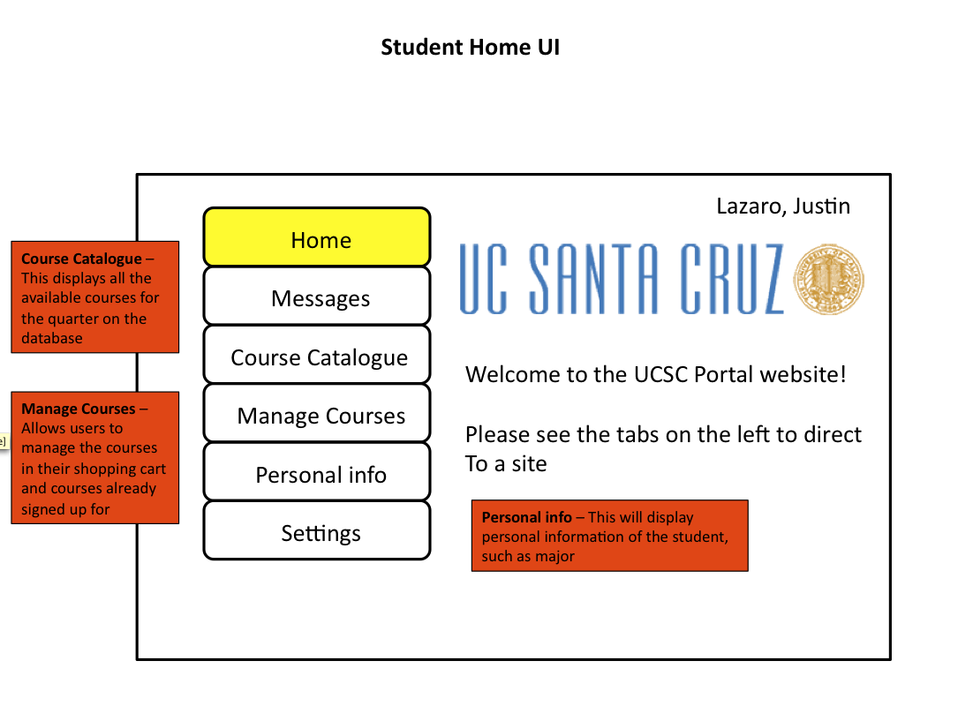

Figure 5.

By this time, the MyCourses Scheduling System is complete and posted on the website. The students can now log into the system and sign up for classes.

1. As the student, you must log into the MyCourses Portal (As shown in section 2.1) and from there will immediately notice that you can sign up for classes. (As seen in Figure 5) By clicking on Course Catalogue, you will see the available classes for the quarter, complete with professor, room number, dates, and specific times. The Personal Information tab will display information, such as type of major, year, transcript, and more. The Messages tab shows information from either a Lecturer or the Program Manager, describing any changes or updates in the scheduling system.
2. Once clicked on Manage Courses, a pull-down menu is then initially shown, (as seen in Figure 6) providing information as to which subjects are available this quarter. Right beside that is a table of courses selected along with the professor with times and dates.
   1. This table next to the pull-down menu will be known as your Shopping Cart. You may select the classes of interest, drop them in your Shopping Cart, and decide with time whether you want to take them or not.
3. Before you may peruse classes in your Shopping Cart, you must first choose which classes you would like to take, and this can be done by going into the Course Catalogue section, deciding the preferred class, and clicking Add Course.
4. Once all classes have been chosen, your Shopping Cart will be full and after deciding which classes are wanted, you can click Submit to sign up for classes.

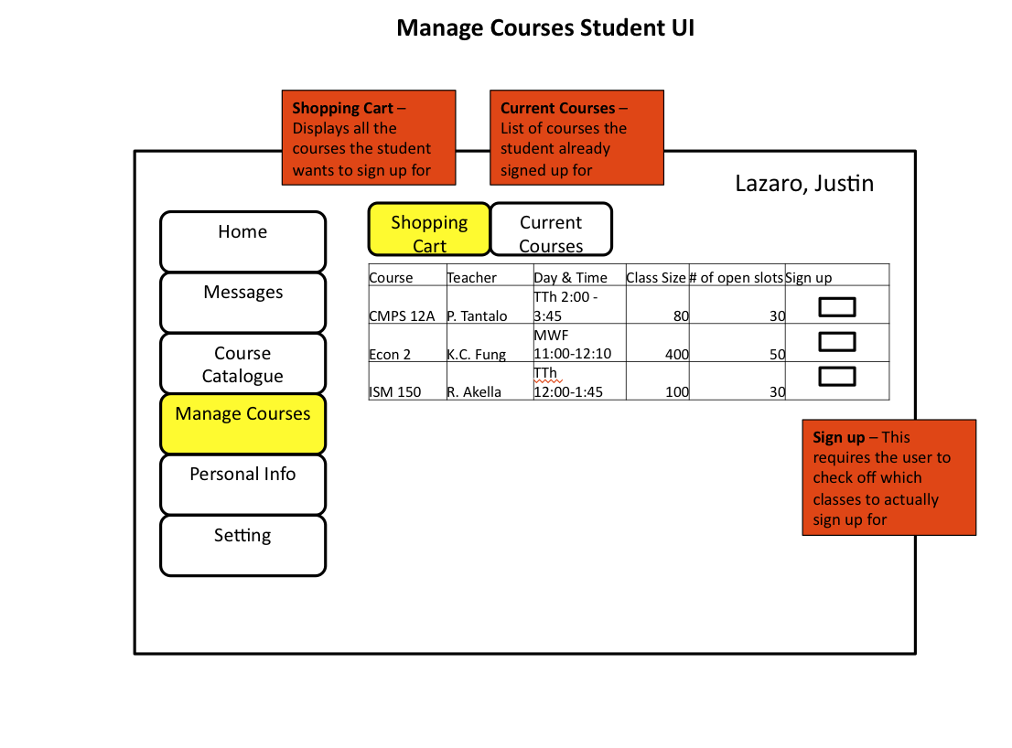

Figure 6.

Index

### MEOW.